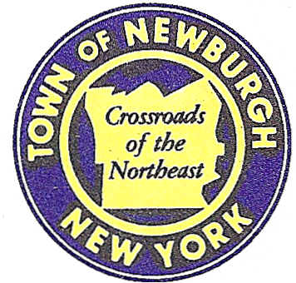

TOWN OF NEWBURGH
_______Crossroads of the Northeast __________________________
OLD TOWN HALL
308 GARDNERTOWN ROAD NEWBURGH, NEW YORK 12550

PLANNING BOARD
JOHN P. EWASUTYN, CHAIRMAN
TELEPHONE 845-564-7804
FAX 845-564-7802
E-MAIL: planningboard@townofnewburgh.org

PLANNING BOARD AGENDA

February 18th, 2016

*PLEASE NOTE: The Planning Board Meeting will start at 7:00 P.M. and all Applicants/Representatives
are to be present at that time. The Meeting will be held in the Meeting Room of Town Hall,
located at 1496 Route 300, Newburgh NY.*

- 128 North Dix (2015-22) PUBLIC HEARING
128 North Dix Ave.
Section 73, Block 7, Lot 22.1
Zone: R-3
Rep: Coppola Associates
6 Old North Plank Rd., Suite 101
Newburgh, NY 12550

2. Matrix Business Park at Newburgh (2015-26) CONTINUATION PUBLIC HEARING
Route 17K
Section 95, Block 1, Lot TBD
(portion of prior Lots 4.12, 54.1, 69.25 & 49.12)
Zone: IB
Rep: Langan Engineering, Environmental,
Surveying & Landscape Architecture
707 Westchester Ave, Suite 304
White Plains, NY 10604

3. Route 300 Realty LLC (2015-30) AMENDED SITE PLAN
128 Old South Plank Road
Section 64, Block 2, Lot 22
Zone: B
Rep: Vincent Doce Associates
242 South Plank Road
Newburgh, N.Y. 12550

4. WTF NY, Inc. (2014-07) INITIAL APPEARANCE
979 & 983 Route 32 LOT LINE CHANGE
Section 2-Block 1- Lot 46 &42
Zone: RR
Rep: Talcott Engineering Design, PLLC.
1 Gardnertown Road
Newburgh, NY 12550

5. Restaurant Depot (2015-33) CLEARING & GRADING PERMIT
NYS Route 300
Section 95, Block. 1, Lot 8
Zone: IB
Rep: Larry Marshall, P.E.
Mercurio Norton Tarolli & Marshall
45 Main Street
Pine Bush, NY 12566

PLANNING BOARD BUSINESS
WORK SESSION

February 18, 2016
5:30 P.M.

1. Trinity Square (06-53): 6 month Extension From 21 February 2016 – 21 August 2016

